RDA Data Fabric IG (DFIG):   
Use Case ZIH

Ralph Müller-Pfefferkorn, Michael Kluge

## 1. Scientific Motivation and Outcomes (max. 0.5 pages)

*Provide a short summary of the scientific or technical motivation for the use case. What would be the best possible outcome and why?*

The Center for Information Services and High Performance Computing (ZIH) is a central unit of the Technische Universität Dresden, one of the largest universities in Germany. On one hand ZIH is the computing centre for the university hosting and providing all essential IT services like network, computing, and storage. On the other hand ZIH is a High Performance Computing resource provider for scientists. In addition ZIH is also part of distributed environments (like Grid Computing infrastructures) university institutions belong to. Finally, about a third of the ZIH staff is involved in a variety of research projects within Germany, the European Union, and worldwide making an integration of infrastructures for research necessary. These research projects deal with diverse data sources like HPC environments or high throughput experiments and cover the complete data life cycle from data generation to archiving.

The variety of functions makes the data fabric that is operated quite complex. It has to handle the requirements of single persons, local and distributed groups for almost all scientific disciplines (natural sciences, engineering, life sciences, humanities, social sciences).

## 2. Functional Description (max. 1 page)

*Give at least one diagram that indicates the overall structure/architecture of the data creation and consumption machinery that is being used in the lab/infrastructure. Describe in simple words the functioning of the machinery.*

The diagram indicates both the current situation as well as future plans (dotted lines).

There are many different data sources like experiments, data collections, or simulations on HPC systems. Usually the first starting point is the “ingest” on a file system where the data are organized in directories. In a next step some communities use more sophisticated data management systems which include metadata management. But the majority of users is still bound to the file system. Some scientists create metadata organized in files or a database.

For work in progress or collaborative work sync&share tools are used for smaller data sets and data transfer services for larger ones. Data preservation is done on three different levels (see below).

In the future a repository will combine long-term preservation and data publication also using external services and allowing access via a web portal.

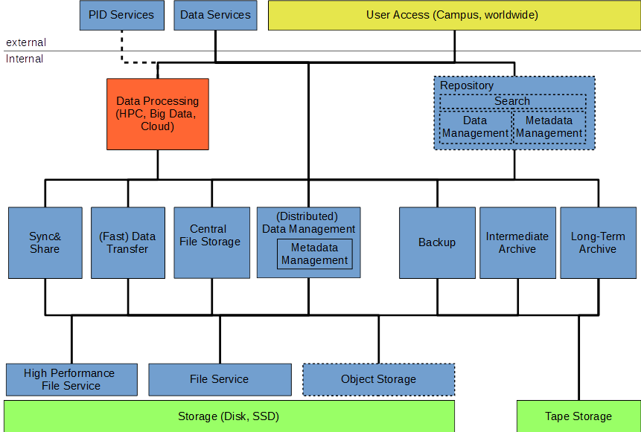

Schematic and simplified view of the infrastructure; dashed lines mark components or connections not yet in production

## 3. Describe essential Components and their Services (max. 1 page)

*Describe the most essential infrastructural components of the machinery and the kind of services they offer. These descriptions don't have to be comprehensive.*

File based services: Still play the most important role for the majority of users. High Performance (parallel) file systems are especially important for fast data access on the HPC system.

Object storage: For the storage of large quantities of data object storage is currently evaluated.

Sync&Share: In the daily research business syncing and sharing small sized data sets easily is an essential feature for collaborative work.

(Fast) Data transfer: Large data sets net to be transferred for processing, for sharing, or between storage facilities.

Central storage: A university wide file storage for every user (home) and for groups. Can be mounted on every device and is used for daily work.

(Distributed) Data Management: Components to manage large data sets and their metadata. Sometimes they provide more features like standardized processing. Communities have preferred solutions and the systems might be included in external data services (e.g. Grid Computing).

Backup: Intermediate storage (order of months) for the recovery of data in case of data loss. Usually used for data in progress.

Intermediate archive: Used to archive data for typical project run times (order of 3 years). The user is responsible for the data. Metadata should be provided, but there are no strict requirements nor search capabilities.

Long term archive: Digital preservation of data for 10 years and longer. Sets strict requirements for metadata, formats, bit stream preservation, data curation, etc.

Repository: A repository will be used to collect and publish data sets. It will be connected to other services like the long-time archive or PID services. It includes components for data ingest, data and metadata management, discovery, and access for data processing. Different access licences are implemented with rights management.

## 4. Describe optional/discipline specific Components and their Services (max. 1 page)

*Describe the most essential infrastructural components of the machinery and the kind of services they offer. These descriptions don't have to be comprehensive.*

As we provide services for a variety of disciplines the components we use are discipline agnostic.

## 5. Describe essentials of the underlying Data Organization (max. 1 page)

*Describe the most important aspects of the underlying data organization and compare it with the model outlined by DFT.*

Due to the broad spectrum of disciplines there is a variety of data organization forms. Nevertheless, common patterns are data objects and data collections. The majority of users saves them in files (objects) and directories (collections) on a file system. Community specific file formats are used as well as common formats (like HDF5 for large files). Only very view researchers use databases.

Especially for large data sets metadata are stored beside the research data, usually in files. Very often collection specific metadata are saved in the “old” style – encoded in directory names.

iRODS and dCache with their data organization principles are also in use or their use is planned by some communities.

For the repository we plan to use the data object/data collection model. Detailed metadata will be preserved with the data in the long-term archive, but will be made available for discovery as well.

## 6. Indicate the type of APIs being used (max. 1 page)

*Describe the most relevant APIs and whether they are open for being used.*

To write and access data in files the POSIX API is used in applications (e.g., in HPC). Currently we are evaluating object storages (like Openstack Swift or Ceph) for production. Other data access or data transfer APIs/protocols/tools in use are WEBDAV, FTP, scp, UFTP or GridFTP. Components in use like iRODS and dCache also provide APIs. For the repository more APIs will be needed e.g. for accessing PIDs.

## 7. Achieved Results (max. 0.5 pages)

*Describe the results (if applicable) that have been achieved compared to the original motivation.*

Most of the components described above are in production or preproduction. Example communities served are genetics, physics, computational fluid dynamics, and engineering. We successfully developed and deployed workflow enhancements for these communities. For the genetics community we have established a large scale workflow capable of analysing millions of images. In our research projects we have typically focussed on providing the scientists with real world solutions that enable new discoveries through the “ease of use” of high performance computing and storage capabilities as well as high speed networks. We participate in testbeds for upcoming network technologies and evaluate soft- and hardware components for future generation computing systems. In addition, we have been working with multiple communities on data management solutions and scientific gateways, for example with the materials sciences and the molecular chemistry community.